Web Development
Individual Assignment
Part 2 – Site Map

Objective:
Create a Site Map for the Personal Portfolio Web Site.

Directions:
Create a site map of your individual project’s web site. Using any graphic type of program that can create rectangles and lines. (like Microsoft Word or Google Draw).

In each rectangle place a descriptive name for a page on your web site. In addition, place a file name in each rectangle that you will use to name that page.

You should have a minimum of 5 web pages. Your project needs to be unique. Be creative what each page will be. Only include pages that will fill one whole page. A bad example would be a page that only has a link to your resume, that would not be a good webpage.

Example:
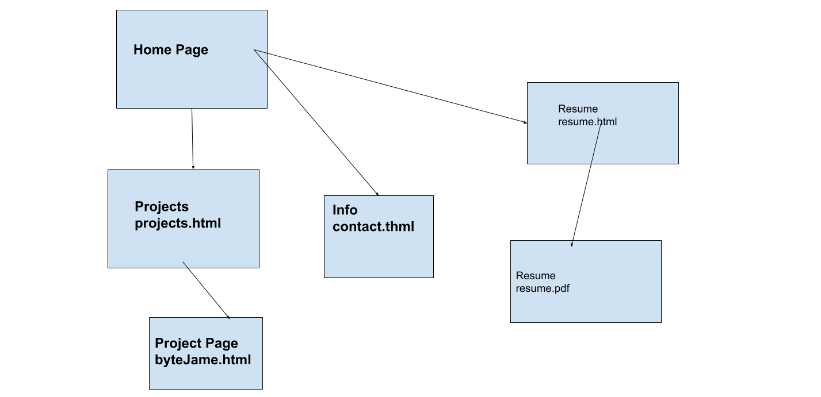

Place this document in your project folder and in the Unit 2 individual project drop box.

Continue to collect items that you will use for your project.

